**RFC-LFP001v2**

**Suggested problem**  
Estimate the HI of dry minerals.

**Suggested solution**

By cross-plotting hydrogen index (HI) against sandstone NPHI and bulk density in Monte Carlo database in appendix A of La Vigne 1994, one gets a good correlation as shown in Table 1. $R^{2}$ for epithermal tool (APS) and thermal tool (CNL) are respectively 0.99 and 0.94. The solution would then to chose between manual value, epithermal correlation, or thermal correlation.  
  
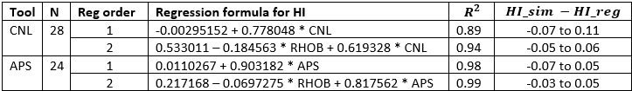 Table 1. Dependence of HI on tool type and sandstone porosity

The first order cases for APS and CNL are shown in resp. Figure 2 and Figure 3.

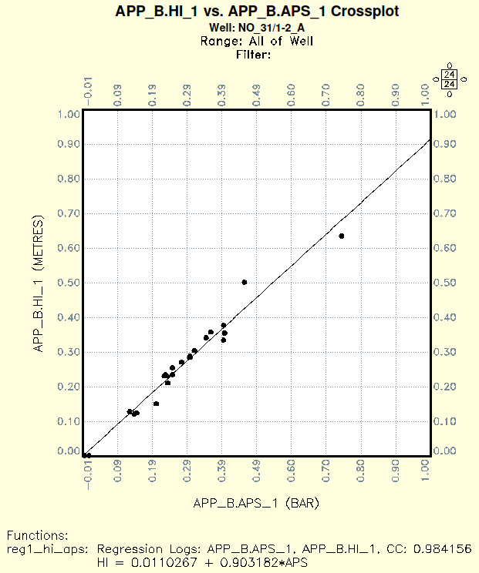Figure 2. Regression order 1 result for APS.

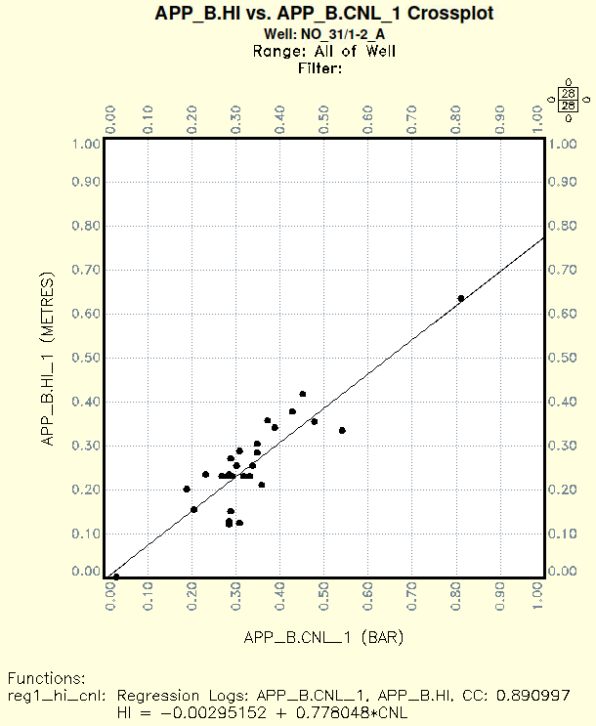  
Figure 3. Regression order 1 result for CNL.

**Reference**

Jack La Vigne, “Density-Neutron Interpretation in Shaly Sands”, SPWLA 35th Ann. Logging Symp., June 19 – 22, 1998, pp. 1 – 16.

**Appendix A – Regression output from Geolog**

**A.1 Epithermal APS**

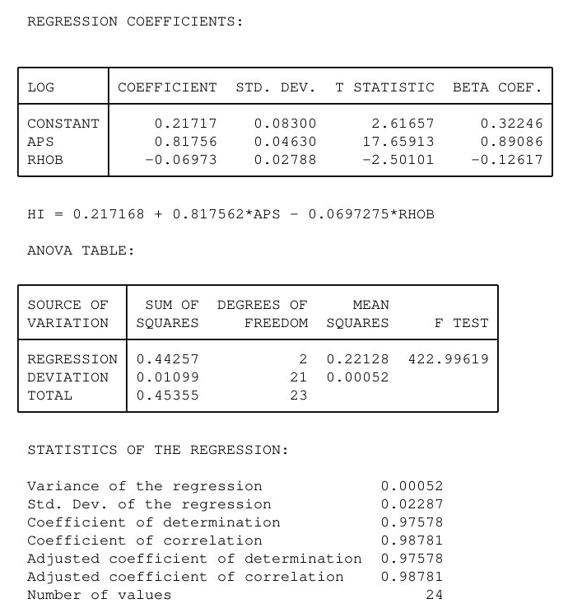

**A.2 Thermal CNL**

